Gubernatorial Tax Proposals and Partisanship

Carlisle Rainey

Kevin Stout

Richard Winters

**Abstract:** Voters often assume that Republicans and Democrats have distinct economic policies. One way for the parties to behave differently is to tax in different ways. Although many previous studies have shown that gubernatorial partisanship is not significant in tax outcomes in each state, this study uses tax policy changes from the governors themselves to determine if governors from different parties try to tax in distinguishable ways. We also use random effects for time and state to examine how the probabilities of eight different tax categories change over years and state. Although there are differences between the parties’ tax policy, our study mostly support previous literature finding gubernatorial partisanship to not be significant in state tax policy.

State budgets are key in determining who gets what and who pays for it. The budget process frequently leads to sharp battles between Democrats and Republicans. Considering each party has its own constituency groups and economic platform, it stands to reason that the parties should want different outcomes in the budget process (Winters 1976). In this study, we focus specifically on state governors and their tax change proposals in order to determine if governors from different parties try to tax in distinct ways.

State governors play a role in state budgeting with many states requiring governors submit their own budgets. This process reveals what the governor values in both tax and spending policy. Although it is up to the legislature to actually legislate a budget, the governor’s voice in the process is the clearest. Considering the governor also holds a partisan label, voters can link parties and tax policy through the tax policies proposed by governors.

Examining governors, partisanship, and tax proposals allows us to evaluate whether Democratic and Republican governors behave differently when it comes to state taxes. State governments have various revenue sources even just across taxes and fees. States impose their own sales taxes, income taxes, corporate taxes, and fees among other taxes allowing state governments to shift the tax burden to different constituencies. However, every state except Vermont must also maintain a balanced budget, constraining governors and legislatures when it comes to funding government operations. If parties intend act on the distinct tax programs they espouse, governors in each state should be making distinguishable tax proposals which align with their respective party platforms.

Using 24 years of governor tax proposal data from every state, this study compares Republican and Democratic governors across eight tax categories and total taxes. The focus is on whether or not an increase, decrease, or no change is proposed by governors. Although both parties are expected to tax differently due to their ideological differences, Democratic and Republican governors behave surprisingly similar in their tax change proposals. This pattern is modeled over time and for each state to show the larger tax trends in each state. The analysis presented here shows how governors from different parties are constrained in their ability to affect tax policy even when they have relative freedom to make proposals in their own terms.

**Previous Findings**

Many studies have examined state taxes, partisanship, and governors, but few have focused on the three together to the extent that this study does. Governors are usually held responsible for the performance of the state economy even though it is arguable about how much single-handed control they have over economic performance and taxes in the state (Niemi, et al. 1995). Much like presidents are given blame or credit for national economic performance, governors can expect to be punished or rewarded based on state economic performance. It makes sense for tax policy choices to influence voters as well.

Although governors can expect reward or punishment based on economic performance, previous work shows that gubernatorial partisanship in mostly irrelevant in tax policy outcomes but partisan control of the legislature is significant (Barrilleaux and Berkman 2003, Dilger 1998, Dennis et al. 2007, Leigh 2008). Dilger (1998) analyzes various state economic factors from 1985 to 1995 and finds that gubernatorial partisanship has little impact. Divided government is an important factor in states’ abilities to pass and balance budgets, (Alt and Lowry 1994, Poterba 1994) indicating that gubernatorial partisanship matters when it differs from the legislative majority party. This raises questions about how much a governor’s party matters on its own in tax policy.

Other studies have looked at the overall tax burden over a longer period and found that taxes are usually higher under Democratic state legislatures compared to Republican ones (Reed 2006). Specifically looking at governors over a 40 year period, there isn’t much of a difference in taxes by party (Leigh 2008). Fredricksson et al. find that the competitiveness of the gubernatorial election and term limits might influence tax policy outcomes between the parties (2013). Contrary to what might be expected, lame duck Democratic governors are more likely to lower income taxes than lame duck Republican governors. Re-electable Democratic governors are more likely to raise income taxes as compared to Republicans. This is attributed to an incumbency advantage where incumbent governors feel that they have the power to move state tax policy towards their ideal point without as much concern for losing because the incumbency advantage is so high.

One way this study differs from these previous studies is in how it uses gubernatorial tax proposals instead of only accounting for the final tax burden. Proposal data better show what a governor would want. The final tax burden can be a complicated outcome with many factors which might dilute the ways in which governors from different parties would want to govern. Previous null findings for gubernatorial partisanship could result from these other institutional or state factors which mediate the tax policy a governor would most like to implement. A better way to assess whether or not governors from different parties are divergent in their tax plans is to use data which is closer to her ideal. The data used in this study strike a balance between observability and gubernatorial ideal. The tax proposals are formal enough and public enough to be coded while the governor still maintains influence in the budget process.

Another possibility is that governors from different parties just tax differently. Dennis et al. find that partisanship influences where governors want to push the tax burden (2007). Democratic governors might push the burden onto the wealthy and businesses through income taxes and corporate taxes while Republican governors might choose to balance the budget by increasing fees or sales taxes. To better account for this possibility, this study uses eight different tax categories, allowing for better understanding of how governors would want to shift the tax burden which could differ depending on partisanship. Previous research shows that Democratic control usually results in more progressive taxation (Dennis et al. 2007). It is likely that corporate taxes and income taxes will be increased by Democrats more than Republicans while fees and sales taxes should be more likely to increase under Republican governors. Sin taxes such as alcohol and tobacco taxes should change similarly for Democratic and Republican governors.

**Data and Model**

Governors in their role as state executives should have some agenda setting influence. When it comes to state budgets, their yearly budget proposals are concrete documents meant to reflect her budgetary views, which should be informed by her party affiliation. Governors write budget proposals addressed to the legislature and to the states’ residents in which she proposes levels for spending and taxes. These documents provide insight into governors’ goals and commitments by showing desired funding levels.

For example, Delaware Governor Jack Markell issued his formal budget proposal for the fiscal year 2015 on January 30, 2014. In the slide show describing his recommended changes, he increases taxes on limited corporations by $50 dollars each and increases the minimum annual corporation franchise tax by $100, resulting in expected added revenue of $51 million (“State of Delaware Financial Overview”, 2014). Rick Snyder, Governor of Michigan proposed changes to the Homestead Property Tax which would result in $102 million less in state tax revenue (“Fiscal Years 2015 and 2016 Executive Budget Recommendation”, 2014). Markell’s actions demonstrate a proposed increase in corporate taxes for Delaware while Snyder’s recommendations are a decrease in taxes labeled ‘other’. These budget recommendations are key in more fully understanding how governors wish to tax. It is much more representative of where we would expect to see partisan impacts in the governor’s office.

Clearly there are many more considerations in the budget process. Many previous studies have shown that the state legislature is more important than the governor in deciding tax and spending policy. However, the legislature is composed of many actors representing many different constituencies statewide (Reed 2006). Whichever party controls the state legislature can enact its economic platform, but this process is much messier than a governor’s proposal.

Aside from the legislature, there are other considerations in tax policy. State wealth creates different situations for which taxes make sense. States with lower incomes are likely to keep their income tax burdens lower since they will be less lucrative or might hinder the state economy. Other traditional controls for state economy like population, urban-rural divide, and economic sectors likely also play a role in determining which taxes governors propose to increase, decrease or leave the same.

Since the focus of this study in on governor party affiliation and overall likelihood of tax changes in states, the model reflects this simplicity. Governors can propose increases, decreases, or no change in tax policy across different tax groups. No change is the most likely scenario, so the data are divided to omit increase or decrease. Thus, the model reflects the likelihood of a proposed increase or no change, omitting the instances of tax decreases. When tax decreases are the outcome variable of interest, increases are omitted.

To model the likelihood of a change in tax policy, a logit model with random effects for state and time is used. Two outcome variables are used in separate models—tax increase proposed and tax decrease proposed. The only independent variable included is the governor’s party affiliation. This model specification means that all the other effects like state legislative partisanship, population, wealth, and any other factor are all reflected in the intercepts. The random effects for time and state show the spatial and temporal trends in tax changes compared to the partisanship of governors.

The governor budget proposal data is collected by the National Association of State Budget Officials. NASBO codes gubernatorial budget proposals across various tax categories which are sales tax, income tax, corporate tax, tobacco tax, gas tax, alcohol tax, all ‘other’ taxes[1], fees, and total taxes. NASBO records the impacts of proposed increases or decreases in terms of millions of dollars in gained or lost revenue to the state. For the purposes of this study, any amount above or below zero is recorded as an increase or decrease respectively. The data span all states from 1989 to 2012 inclusive, except 2009 is missing. Governor partisanship is Democratic or Republican.[2] Random effects are utilized to model variation across states and years. Each tax category is modeled separately with proposed increases or decreases in each category, resulting in 18 total models.

**Partisan Effects of Governors**

Each tax category has two models with a dummy variable for the governor’s party, allowing us to see how governors from different parties might tax differently. It is important to remember that these are tax proposals made by governors. The actual tax policy passed from the state legislature is almost certain to be different from what the governor proposed. These gubernatorial suggestions aren’t directly translated into tax policy, but this situation should allow governors to make suggestions with fewer constraints. Although this process is formalized, governors have the ability to ground their policy in ideology since it is part of a larger negotiation process between the governor and the legislature. Tax policy is more grounded in the needs of the situation than say a campaign promise, but still affords governors the leeway to design tax policy as closely as possible to their ideal.

Governors should be designing tax policy closely to their desires with constraints being the state’s financial situation and the political situation. 49 states have balanced budget amendments (NCSL.org) which means that tax policy has to be realistic enough to meet that goal.[3] Governors might also propose taxes in a way to hope that the legislature implements his or her plan. An extremely conservative governor might compromise on his or her tax proposal in hopes that a liberal legislature seriously considers the proposal. The balancing act is up to the governor though, so the tax policy proposal should be mostly a representation of the governor’s ideological views informed by budgetary and political realities. In the end, the proposals are the most realistic form of a governor’s tax views.

Figure 1 shows the predicted probabilities of a tax increase or decrease in each tax category. Red triangles show the probabilities of a proposed change for Republican governors and blue dots show the same information for Democratic governors. It is clear from this chart that there is little difference between the two parties’ governors. Aside from fees, ‘other’, and total taxes, the two shapes are almost directly on top of each other. Republican governors are slightly more likely to propose increases in fees and total taxes whereas Democratic governors are slightly more likely to propose tax increases for taxes in the ‘other’ category. Aside from these instances, the two parties’ governors appear to behave very similarly when it comes to proposed tax increases.

Concerning decreases, there is a bit more separation between the parties. Republican governors are slightly more likely to propose decreases in the corporate tax, income tax, ‘other’ taxes, and taxes overall. Democratic governors are slightly more likely to propose lower sales taxes. Fees, gas taxes, alcohol taxes, and tobacco taxes are not likely to see decreases no matter the governor’s party affiliation. It might be surprising to see that Republican governors are more likely than Democrats to propose tax increases, but they are also more likely to propose overall tax decreases.

Although the differences between the parties are slight in many cases, are the differences statistically significant? Figure 2 demonstrates that a few of the differences are indeed significant, especially for tax decreases. Figure 2 reports risk ratios for the tax categories. A risk ratio above one means Democratic governors are more likely to propose an increase or decrease. Risk ratios below one indicates that Republican governors are more likely to propose a change in that tax category. Black bars represent 90% confidence intervals. If the confidence interval crosses one, the difference between the parties is not statistically significant. Looking at increases, Republican governors are more likely to propose an increase in fees. When it comes to increases in other tax categories, the parties are indistinguishable.

Three taxes are statistically significant between the parties when considering decreases. Republican governors are more likely to propose decreases for ‘other’ taxes and for taxes overall. Democratic governors are more likely to propose sales tax decreases. The two parties are indistinguishable for all other tax decreases. Figure 3 communicates the same comparison between the parties but in the form of first differences. The predicted probability of tax action for a Democrat is subtracted by the probability of action from a Republican governor. A black bar contacting the zero line indicates that the parties’ proposals are not statistically distinguishable from each other.

**Time Effects**

The preceding section demonstrated that governors of both parties propose taxes in largely the same way. Although both parties campaign on different economic platforms and voters expect them to behave differently, governors themselves choose to propose tax policy which is mostly similar even across different tax categories. Despite many ways to have distinction, the parties converge towards similar considerations. Given the similarity, it is useful to look at this trend over time.

The change in probability of tax action over time is reflected in random effects built into the models. The graphs in Figure 4 represent the probability of tax increases or decreases over time. Red lines represent the probabilities for Republican governors and the blue line shows the probabilities for Democratic governors. Since partisanship is the only independent variable other than the temporal random effects, the lines track with each other across years. For many of the tax categories, the lines are very close to one another. This once again indicates how similar the governors from different parties behave.

Looking at the probability of tax changes over time, it appears that tax changes were less likely in the mid-1990s. For many of the tax categories, the lines sharply decline during this time. The random effects show how probabilities can change from year to year over the time period of the data. Governors can expect to be punished if they raise taxes particularly when the economy is performing poorly (Niemi, et al., 1995). Therefore, tax increases should be less likely when the economy is shrinking.

Figure 5 shows temporal random effects of overall taxes, corporate taxes, income taxes, and sales taxes against national GDP growth. It would likely be more appropriate to compare each state’s GDP growth against yearly random effects, but the national measurement allows us some insight into the interplay between tax changes and the economic climate. Figure 5 demonstrates how tax increases are mostly unresponsive to national economic trends. There is possibly some tracking against GDP in some years for overall tax increases, but especially for the three tax categories there appears to be little movement over time compared to annual GDP growth.

Figure 5 reveals a greater relation between tax decreases and national economic performance. For each of the three sharp declines in GDP within the time frame there was an uptick in the predicted probability of governors proposing overall tax decreases. The probability of corporate tax decreases spikes upward for two out of the three major GDP drops. Income taxes track especially well. The probability of income tax decreases goes down during boom years but went up during GDP drops. Sales taxes behaved in a similar manner to corporate taxes. When the economy shrank around 2001 and 2008-2009, there was an increased probability of governors proposing tax cuts in these major categories. The response was not as uniform for the 1991 downturn, interestingly. Overall, Figure 5 suggests tax decreases rather than increases are more linked to economic performance.

**State Effects**

Differences between the parties are small, but the previous section demonstrates how there is more variation over time. As with the changing probabilities over time, each state has different effects for each tax category. By modeling the state effects, the differences between states is clear.

Figure 6 shows the probabilities for states for each tax category and whether it is an increase or decrease. Darker colors represent higher chances of a tax change proposal. This effect is pooled over time to show the probability over the time period of the data.

Clearly there is quite a lot of variation between states. Many states in the northeast and Great Lakes region see a lot of action on the major taxes like sales, income, and corporate taxes. In the Deep South and some western states there is less activity on taxes generally. Tobacco taxes, gas tax, and alcohol tax only a few instances where governors proposed decreases, which is expected.

Another thing to notice about the maps is how increases and decreases are usually high or low jointly in the same state. New York and Minnesota both tend to have high state effects for the probability of proposed increases and decreases while states like South Dakota, Wyoming, and Alabama have low probabilities of tax changes.

There are a few possible explanations for this. States with higher probabilities of change might experience more tax policy change proposals. This can indicate the salience of tax and budget issues in each state. Alabama and Wyoming might not see a lot of change from governors because taxes and fees don’t emerge as governing issues often.

Another possibility is that governors in state with many changes are trying to influence the tax policy process more than in states where governors aren’t proposing many changes. Governors might be proposing tax changes to highlight their views and be seen as an active force in the state.

Thirdly, governors may propose more changes to draw distinctions between themselves and their state legislatures. The state legislature may be likely to behave in some way when it comes to taxes so a governor proposes changes that show how he or she disagrees with the legislatures’ agenda. In states like South Dakota, Montana, and Nevada it might be that the governor’s tax agenda tends to line up with the legislature’s policy.

Lastly, variation in state tax policy might be attributed to state political culture. Past research has shown political culture to impact state political institutions (Elazar 1972, Lieske 2009, Erikson et al. 1993). It is likely that political culture also contributes to the way governors behave when considering their own tax agenda for the state.

**Conclusion**

Economic policy and taxation are topics which can dominate political campaigning between parties. Candidates expend time and energy drawing distinctions between each other. It is reasonable for voters to expect these candidates to then behave differently. The Republican and Democratic parties have mostly cohered around different tax platforms, further reinforcing the sense that governors from the two parties should govern differently.

This study has demonstrated how Democratic and Republican governors mostly govern similarly when it comes to tax policy. When governors themselves are empowered to design tax proposals, governors from different parties should take this freedom create distinguishable tax platforms. However, even when eight different tax categories are taken into consideration, governors from the two parties are proposing increases and decreases very similarly. Significant differences only exist in that Republicans are more likely to increase fees, decrease ‘other’ taxes, and decrease taxes overall. Democrats are more likely to decrease the sales tax compared to Republicans. Other than these instances, voters would expect to see similar proposals from governors of either party.

Governors must be facing other constraints when it comes to taxes which prevents them from proposing taxes in a way guided by party ideology. The variation over time shows how governors are likely sensitive to the economic climate so that both parties have governors making similar decisions even across tax types. State effects show that governors are also likely constrained by state institutions like the legislature, state economic conditions, and political culture. These constraints outweigh the partisan differences in most cases. Although voters might perceive governors to have lots of control over taxes and the state budget, a wide gulf between the parties does not exist when it comes to governors.

Figure 1

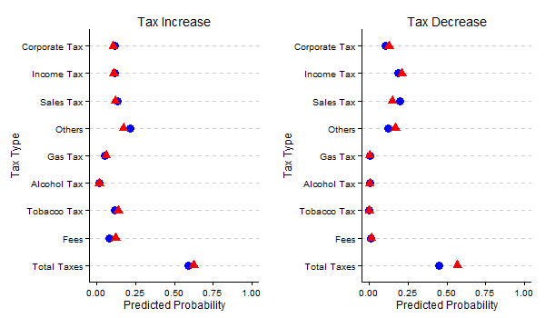

Figure 1 shows the predicted probabilities of tax changes across different tax categories. Red triangles represent probabilities for Republican governors while blue dots represent probabilities for Democratic governors.

Figure 2

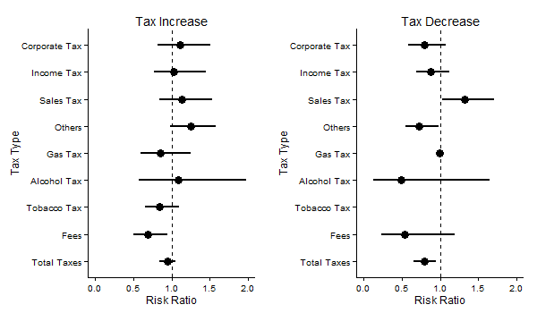

Figure 2 shows the risk ratio for partisanship across tax categories. A risk ratio above 1 means that Democratic governors are more likely than Republican governors to propose an increase or decrease while a risk ratio below 1 indicates that Republican governors are more likely to propose action. Tobacco tax decreases do not appear because the point estimate and interval is outside the range. The confidence interval for gas taxes is also so large that it encompasses the whole range from 0 to 2.

Figure 3

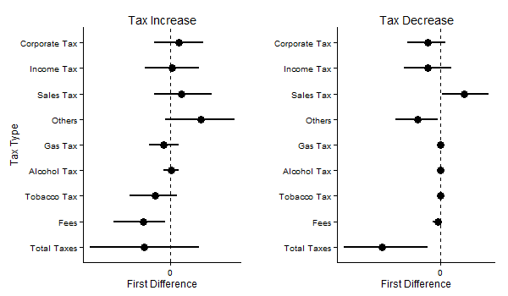

Figure 3 shows the partisan difference between governors by using first differences. Democratic probabilities are subtracted from Republican probabilities, meaning differences above 0 indicate that Democratic governors are more likely to propose a change in that category. On the decreases graph, the confidence intervals for gas tax, alcohol tax, tobacco tax, and fees all appear but are so small that it is difficult to see them. All cross the 0 threshold.

Figure 4: Random Effects by Tax Type for Year, 1989-2012

|  |  |
| --- | --- |
| C:\Users\Sheryl\Documents\PSC 631 Adv. Stats\State Taxes\CorporateGraph.png | C:\Users\Sheryl\Documents\PSC 631 Adv. Stats\State Taxes\IncomeGraph.png |
| C:\Users\Sheryl\Documents\PSC 631 Adv. Stats\State Taxes\SalesGraph.png | C:\Users\Sheryl\Documents\PSC 631 Adv. Stats\State Taxes\OtherGraph.png |
| C:\Users\Sheryl\Documents\PSC 631 Adv. Stats\State Taxes\GasGraph.png | C:\Users\Sheryl\Documents\PSC 631 Adv. Stats\State Taxes\AlcoholGraph.png |
| C:\Users\Sheryl\Documents\PSC 631 Adv. Stats\State Taxes\TobaccoGraph.png | C:\Users\Sheryl\Documents\PSC 631 Adv. Stats\State Taxes\FeesGraph.png |
| C:\Users\Sheryl\Documents\PSC 631 Adv. Stats\State Taxes\TotalGraph.png | |

Figure 4 graphs random effects for time for each tax category. Red lines indicted effects for Republican governors and blue lines indicate effects for Democratic governors.

Figure 5: Temporal Random Effects and National GDP Growth

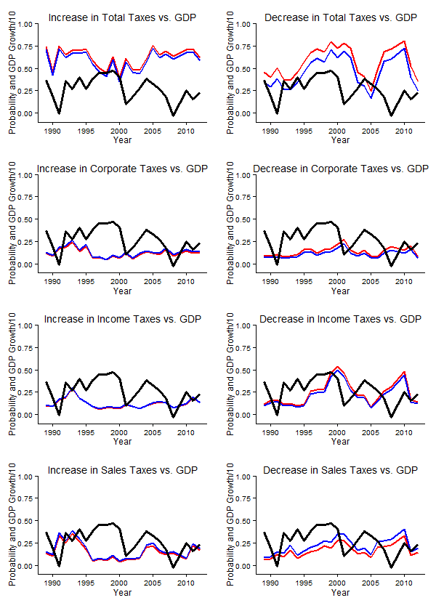

Figure 6: State Effects by Tax Type

|  |  |
| --- | --- |
| C:\Users\Sheryl\Documents\PSC 631 Adv. Stats\State Taxes\CorporateMap.png | C:\Users\Sheryl\Documents\PSC 631 Adv. Stats\State Taxes\IncomeMap.png |
| C:\Users\Sheryl\Documents\PSC 631 Adv. Stats\State Taxes\SalesMap.png | C:\Users\Sheryl\Documents\PSC 631 Adv. Stats\State Taxes\OtherMap.png |
| C:\Users\Sheryl\Documents\PSC 631 Adv. Stats\State Taxes\GasMap.png | C:\Users\Sheryl\Documents\PSC 631 Adv. Stats\State Taxes\AlcoholMap.png |
| C:\Users\Sheryl\Documents\PSC 631 Adv. Stats\State Taxes\TobaccoMap.png | C:\Users\Sheryl\Documents\PSC 631 Adv. Stats\State Taxes\FeesMap.png |
| C:\Users\Sheryl\Documents\PSC 631 Adv. Stats\State Taxes\TotalMap.png | |

Figure 6 shows random effects for each state for each tax category. Darker shades of orange indicate greater probabilities of governors in that state proposing a certain tax increase. Darker shades of purple indicate greater probabilities of governors in that state proposing a certain tax decrease.

Works Cited

Alt, James E., and Robert C. Lowry. 1994. “Divided government, fiscal institutions, and budget deficits: evidence from the states. American Political Science Review. 88: 811-828.

Barrilleaux, Charles, and Michael Berkman. "Do governors matter? Budgeting rules and the politics of state policymaking." *Political Research Quarterly* 56.4 (2003): 409-417.

Dennis, Christopher, William S. Moore, and Tracey Somerville. "The impact of political parties on the distribution of state and local tax burdens." *The Social Science Journal* 44.2 (2007): 339-347.

Dilger, Robert Jay. "Does Politics Matter? Partisanship's Impact on State Spending and Taxes, 1985-95." *State & Local Government Review* (1998): 139-144.

Elazar, Daniel Judah. *American federalism: A view from the states*. Harper & Row, 1972.

Erikson, Robert S., Gerald C. Wright, and John P. McIver. 1993. Statehouse Democracy: Public opinion and policy in the American states. Cambridge: Cambridge University Press, Cambridge.

2014. “Fiscal Years 2015 and 2016 Executive Budget Recommendation” http://www.michigan.gov/documents/budget/A_446646_7.pdf accessed December 4 2014.

Fredriksson, Per G., Le Wang, and Patrick L. Warren. "Party Politics, Governors, and Economic Policy." *Southern Economic Journal* 80.1 (2013): 106-126.

Leigh, Andrew. "Estimating the impact of gubernatorial partisanship on policy settings and economic outcomes: A regression discontinuity approach." *European Journal of Political Economy* 24.1 (2008): 256-268.

Lieske, Joel. "The changing regional subcultures of the American states and the utility of a new cultural measure." *Political Research Quarterly* (2009).

Niemi, Richard G., Harold W. Stanley, and Ronald J. Vogel. "State economies and state taxes: Do voters hold governors accountable?." *American Journal of Political Science* (1995): 936-957.

Poterba, James M. 1994. States responses to fiscal crises: the effects of budgetary institutions and politics. Journal of Political Economy. 102: 799-821.

Reed, W. Robert. "Democrats, republicans, and taxes: Evidence that political parties matter." *Journal of Public Economics* 90.4 (2006): 725-750.

2014. “State of Delaware Financial Overview.” http://budget.delaware.gov/fy2015/documents/budget-presentation.pdf accessed December 4 2014.

U.S. Bureau of Economic Analysis. “Table 1.1.1 Percent change from preceding period in real gross domestic product.” www.bea.gov accessed December 4 2014.

Winters, Richard. "Party control and policy change." *American Journal of Political Science* (1976): 597-636.

1. ‘Other’ taxes are likely to include property taxes and estate taxes among other possibilities.
2. Independent governors are omitted.
3. Vermont is the exception.